

**Faculty of engineering - Shoubra**

**Benha University**

**Research Article**

in fulfillment of the requirements of

|  |  |
| --- | --- |
| **Department** | **Engineering Mathematics and Physics** |
| **Division** | **-------** |
| **Academic Year** | **2019-2020 Preparatory** |
| **Course name** | **Computer** |
| **Course code** | **ECE001** |

**Title: -**

**Programming Languages**

By:

|  |  |  |  |
| --- | --- | --- | --- |
|  | Name | Edu mail | B. N |
| 1 | محمود نادر محمود عمر | Mahmoud195970@feng.bu.edu.eg | 869 |

**Approved by:**

|  |  |
| --- | --- |
| Examiners committee | Signature |
| Dr. Ahmed Bayoumi |  |
| Dr. Shady Elmashad |  |
| Dr. Abdelhamid Attaby |  |

**Application brief**

Programming is the art and science of translating a set of ideas into a program. By turning these ideas to set of instruction so computer can perform what you want. Programing language is a set of instruction use to create software programs. they are used to control the performance of a machine or to express algorithms. programming languages can be divided into two main parts first, high-level languages which we write the code with as it is easy to read not a complicated language this language is compiled into low-level language and it consists of binary code that are understood immediately by CPU.

Example for high-level languages: -

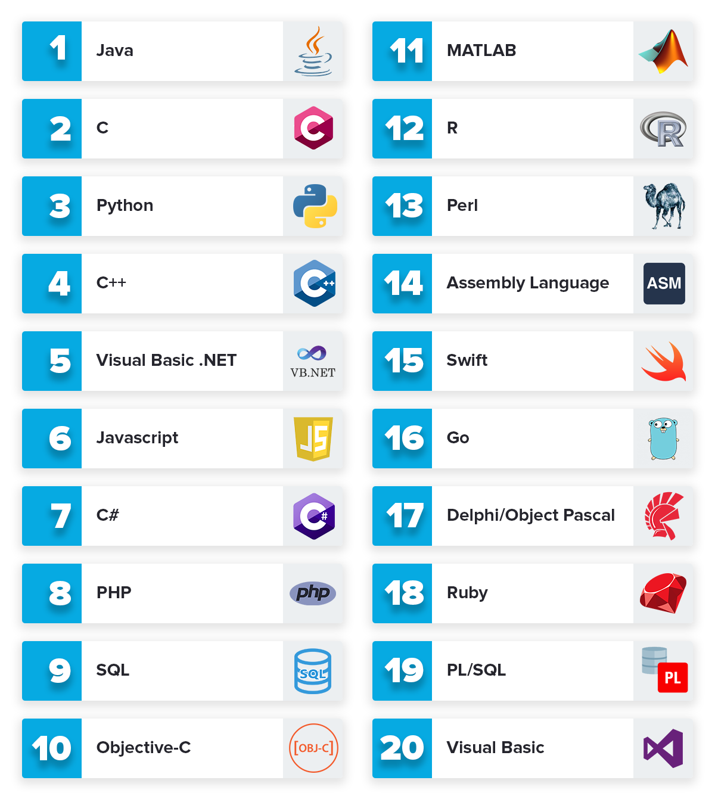

**Types of Applications of programming: -**

1. 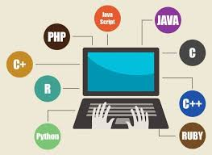Desktop GUI Applications
2. Mobile Applications
3. Embedded Systems
4. Web Applications
5. Web Servers and Application Servers
6. Enterprise Applications
7. Scientific Applications
8. Performing big data analysis
9. Making games
10. Operating Systems
11. Advanced Computation and Graphics
12. Banking Applications
13. Cloud/Distributed System
14. Compilers

**Github link: -**

**Github page: -**

Source code screenshots: -

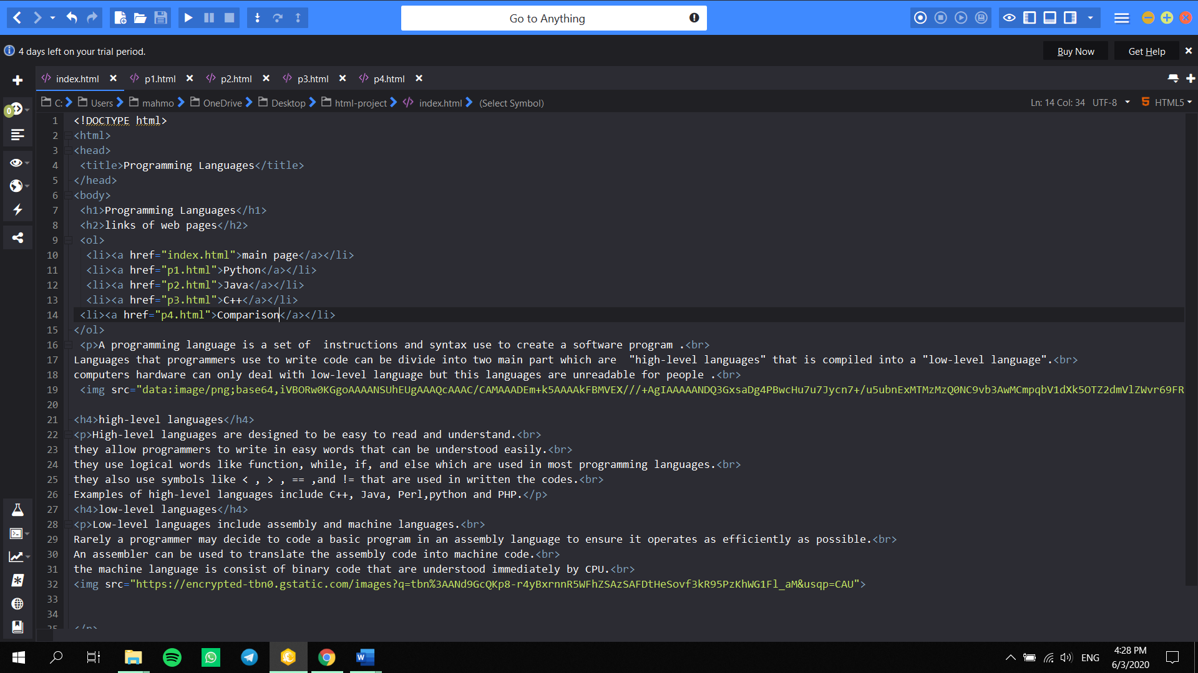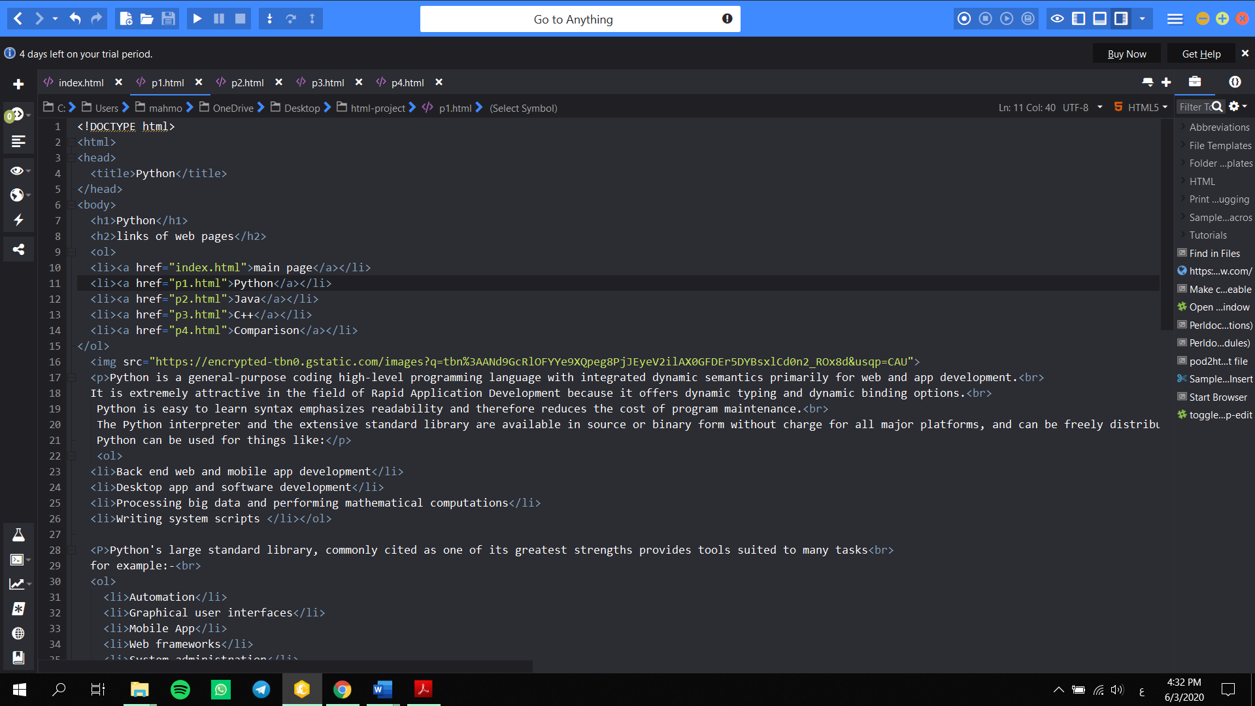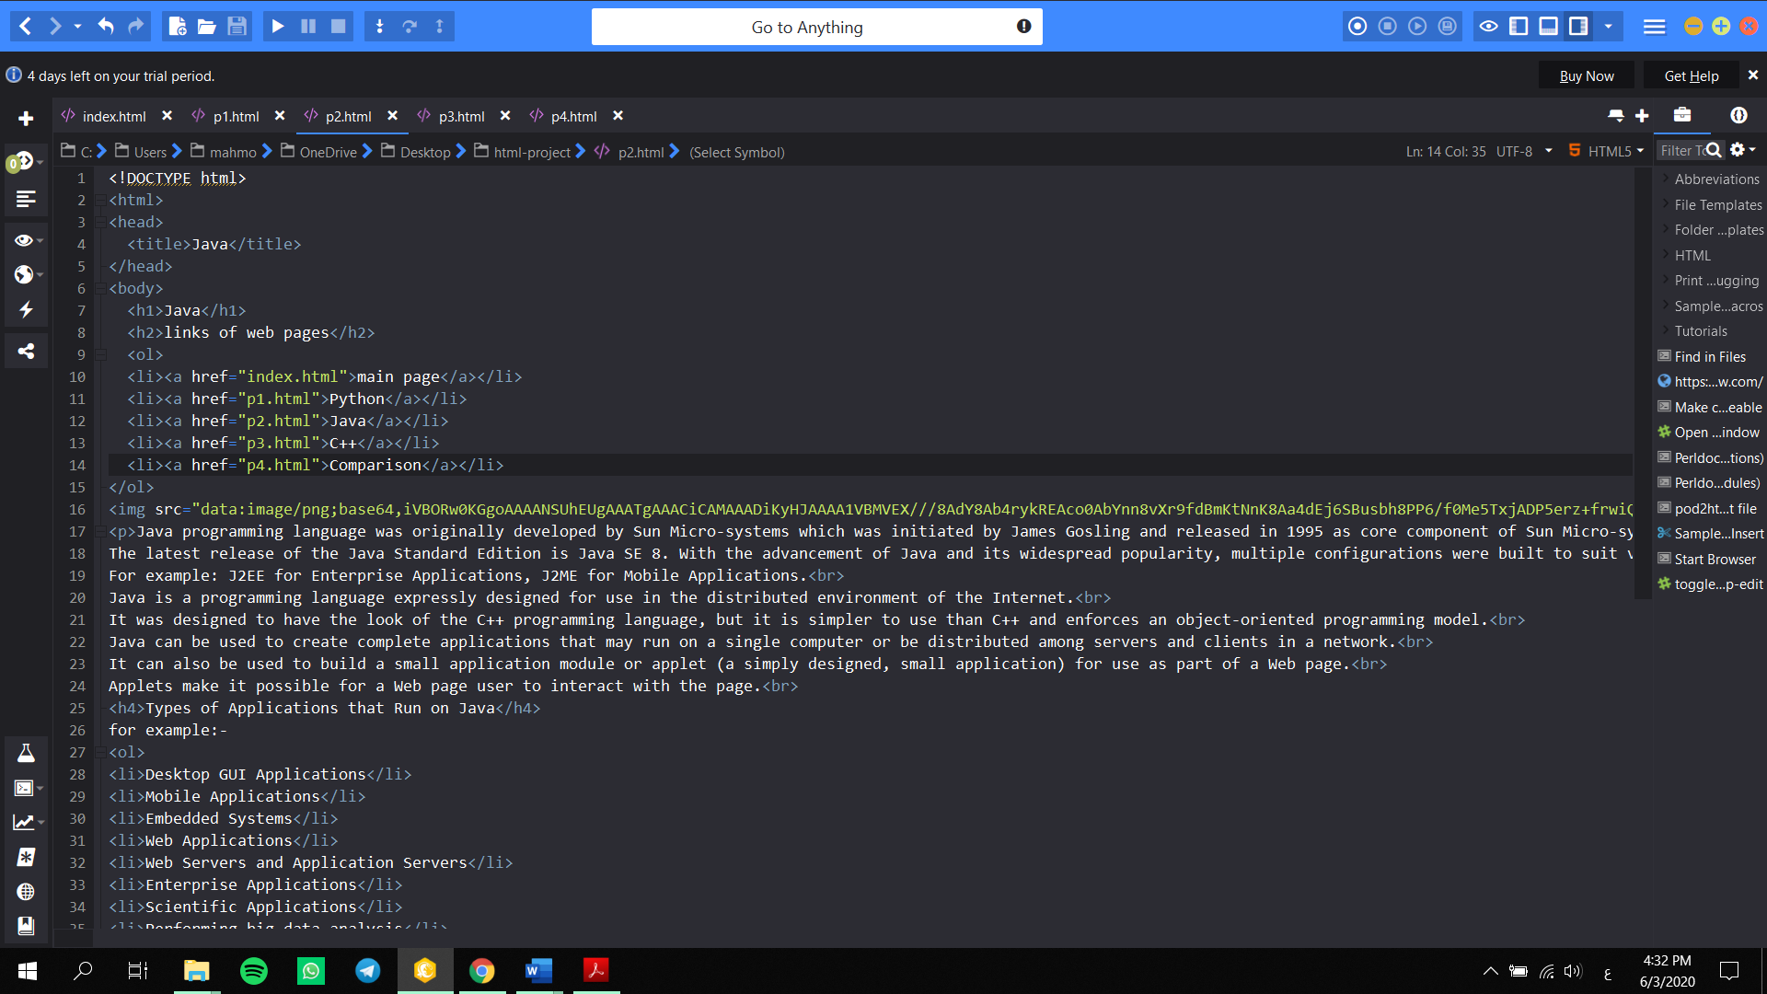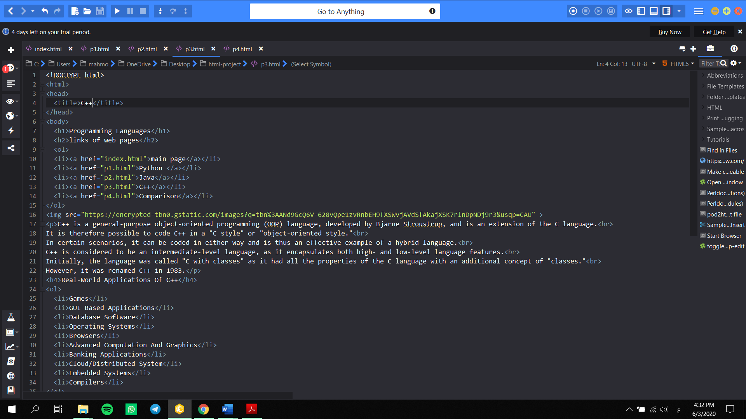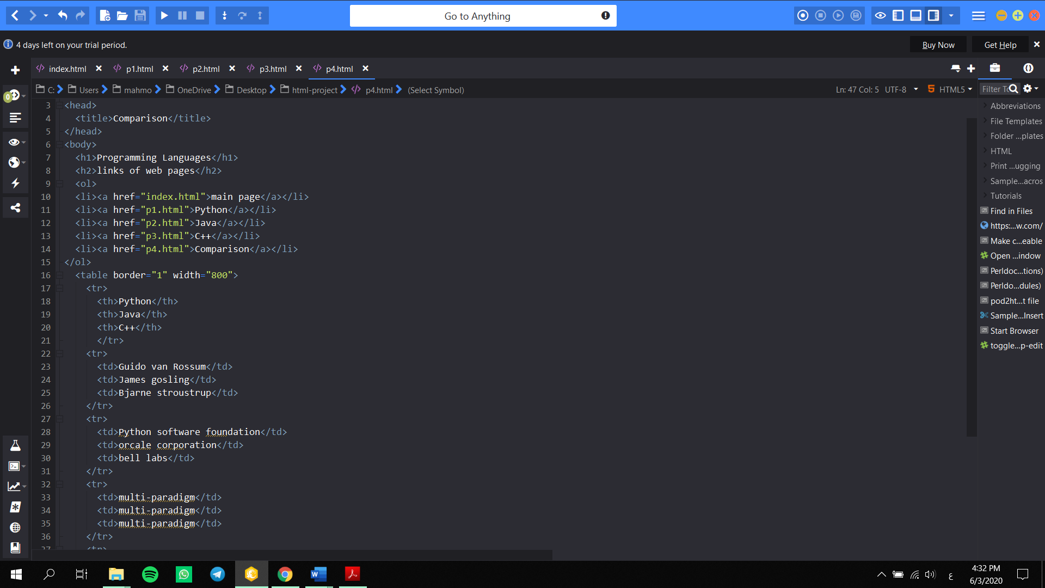

**Website screenshots: -**

